OOP concept using JAVA
____________________________________________________________________
Polymorphism
__________________________________________________________________
Q. What is Polymorphism?
_______________________________________________________________
Polymorphism means if same thing perform different behavior in different situation as per the requirement called as polymorphism.

Example: If we think about mobile it is best example of polymorphism because if we want to call we can use mobile as phone, if we want to watch video we can use mobile as TV, if we want to find the location then we can use mobile as guide, if we want to capture pic we can use mobile as camera
Means we can say we have only one thing known mobile but we can use it as differently in different situation according to user so we can say mobile is example of polymorphism.

Example: if we think about person then if person is an employee of some company then behave as employee in front of boss but if he has own team and if he is team leader then behave like as boss , if he is with his wife then behave like as husband with child behave like parent etc
Means we can person is thing and can change its behavior according to his requirement so we can human or person is best example of polymorphism.

How to implement the polymorphism in programming or using java
________________________________________________________________
If we want to implement polymorphism we have two ways
1. By using compile time technique or compile time polymorphism
2. by using run time technique or run time polymorphism or dynamic polymorphism.

Compile time polymorphism:
Q. What is compile time polymorphism?
___________________________________________________________________
Compile time polymorphism means if functionality bounded with object at program compile time called as compile time polymorphism.

Q. What is run time polymorphism?
____________________________________________________________________
Runtime polymorphism means when we bound functionality with object at program run time called as runtime polymorphism or dynamic polymorphism or late binding & we can achieve run time polymorphism we can use function overriding etc

Q. How we can achieve compile time polymorphism or implement compile time polymorphism?
_________________________________________________________________________
If we want to achieve compile time polymorphism we can use function overloading technique.

Q. What is function overloading?
__________________________________________________________________________
When we define multiple function with same name using different parameter, with different data type with different parameter sequence called as function overloading.

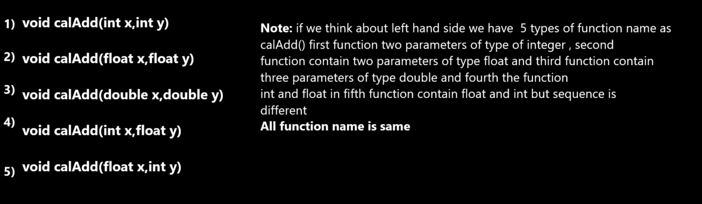

If we want to work with function overloading we should have to know some important points or rules

1. Multiple function names must be same
2. Return type is not consider in function overloading
The meaning of above statement is we can give different return type to every function
definition if required
3. Function parameter type or list of parameter or sequence of parameter must be different
4. Function calling is dependent on number of parameter pass in it and it sequence and dependent on its data type.

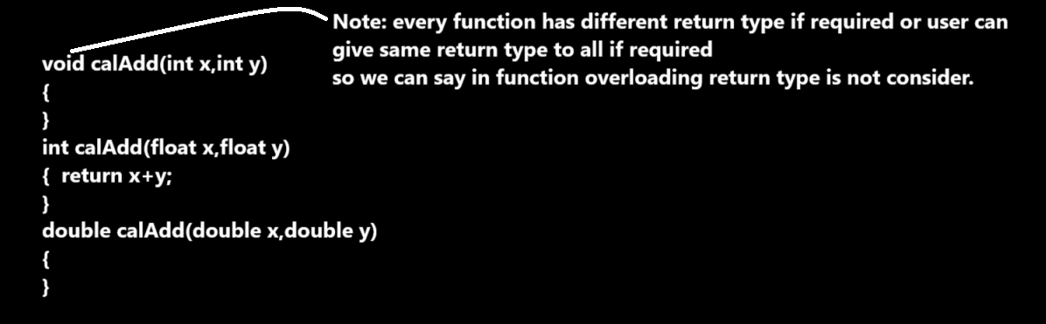

Example with source code
___________________________________________________________________________
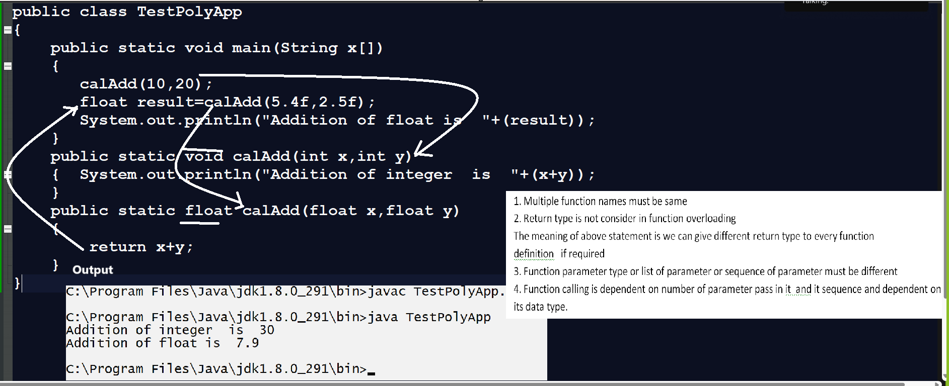
Source code
public class TestPolyApp
{
public static void main(String x[])
{
calAdd(10,20);
float result=calAdd(5.4f,2.5f);
System.out.println("Addition of float is "+(result));
}
public static void calAdd(int x,int y)
{ System.out.println("Addition of integer is "+(x+y));
}
public static float calAdd(float x,float y)
{
return x+y;
}
}

Q. Why use function overloading or what is benefit of function overloading?
______________________________________________________________________
if we have some requirement under same domain with multiple logics then we required to write multiple functions for implement logic with different function name but the limitation is developer need to remember all function name at the time of calling so it is very tedious task when we have multiple logics so standard is write all function with same name and with different logics called as function overloading so the benefit developer not need to remember the different function name just he need to remember single function name and can pass different parameters according to logics

Scenario
Suppose consider we are working of billing application for particular shop or hotel
Then there may different kinds of bills means we need to write logic for bills
suppose we have two types of bill like as
bill with gst, bill without gst so we required to functions with different name so better way you can define two functions with same name so we not need to remember two different function name just we can remember single function name it is benefit of overloading
Note: here billing is our domain and bill with gst or bill without gst is logic or behavior of bill

Example with source code
public class BillingApp
{
public static void main(String x[])
{ calBill(10,100); //call bill without gst logic
calBill(10,100,18); //call bill with gst logic
}
public static void calBill(int qty,int rate)
{
System.out.printf("Bill without gst %d\n",qty*rate);
}
public static void calBill(int qty,int rate,int gstRate)
{
int total=qty*rate;
int gstAmt=(total*gstRate)/100;
total=total+gstAmt;
System.out.printf("Bill with gst %d\n",total);
}
}
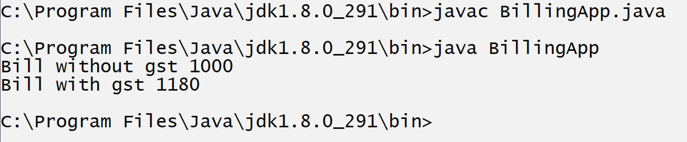

Interview Question (Date : 9/11/2024)
Q1. What is polymorphism?
Q2. Types of Polymorphism and how we can implement it?
Q3. What is function overloading?
Q4. Explain rules of function overloading with example?
Q5. Explain benefit of function overloading with scenario except class example?

Program
______________________________________________________
Q1. WAP to perform sorting using function overloading
void sort(int a[]): this function can accept integer array and sort it
void sort(char[]): this function can accept string array and sort or character array and sort it

Q2. WAP to perform following operations
void area(float) : this function can accept radius of circle and calculate area of circle
void area(int wid,int height): this function can accept width and height of rectangle and calculate area of rectangle

Q3. WAP to perform sum operation using overloading
void calSum(int a[]): this function can accept integer array and calculate sum of all elements
void calSum(char[]): this function can extract digit from character array and calculate its sum
Example:abc123mno
Output: 1+2+3 = 6

